RC Hovercraft

The aim of this project was to design, analyse and manufacture a fully working small scale model of a remote controlled hovercraft.

# Functional Decomposition:-

Lift - Hull propeller is used to propel air in the nylon skirt thrugh the hull, which contains the air and forms an air cushion beneath the hovercraft

Thrust - A thrust propeller is bounted on the back of the body which is used to generate the thrust required for hovercraft movement

Steering - A rudder is installed behind the thrust propeller which is used to steer the hovercraft. The rudder is controlled using a microcontroller which can receive input remotely using a radio transmitter-reciever

# Design and Analysis



*Hull Design Dimensions*

# Calculations

Base Area= 45313 mm2

Perimeter= 833 mm

Pressure required in air cushion for hovering= Weight/Area

If Weight=5kg, Pressure=1081 Pa

If Weight=10kg, Pressure=2163 Pa

Applying Bernolii’s Theorm:-

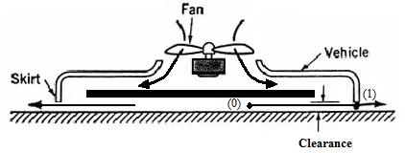

$$\frac{P_{0}}{ρ}+\frac{{v_{0}}^{2}}{2g}+z_{0}=\frac{P_{1}}{ρ}+\frac{{v_{1}}^{2}}{2g}+z_{1} ∀ v_{0}=0, { z }_{0}≈z_{1}, { P}_{2}=0$$

$$∴ v_{1}=\sqrt{\frac{2P_{0}g}{ρ}} ∀ ρ=1.225 kg/m^{3}$$

When weight=5kg

Leakage air velocity=132m/s

When weight=10kg

Leakage air velocity=186m/s

Leakage volumetric flow rate (LVFR) = Perimeter x Clearance x Leakage Air Velocity

If Clearance= .5 mm

Weight= 5 kg

LVFR= .055 m3/sec

If Clearance= 2 mm

Weight= 5 kg

LVFR= .22 m3/sec

If Clearance= .5 mm

Weight= 10 kg

LVFR= .0775 m3/sec

If Clearance= 2 mm

Weight= 10 kg

LVFR= .31 m3/sec

Inlet Area= 3850mm2

Inlet velocity= LVFR/Inlet Area Inlet

Volumetric flow rate (Cubic Feet per min) = LVFR x 35.315 x 60

Inlet velocity= 14m/s

CFM= 117

Inlet velocity= 57m/s

CFM= 466

Inlet velocity= 20m/s

CFM= 164

Inlet velocity= 80m/s

CFM= 657

The CFM calculated was used to estimate the specifications of Lift Propeller and Motor.



*CAD model*



*Cut Section Views*





*Meshed internal Air Volume of Hovercraft*

Meshing conditions for Air Volume for Momentum Curtain Theory and Plenum Theory:-

Tetrahedral mesh with boundary prism elements

Default body spacing (maximum)- 0.01

Default face spacing (minimum & maximum edge length)-0.001 and 0.02

Boundary conditions to model CFD analysis for Momentum Curtain Theory and Plenum Theory:-

Inlet – 0-60m/s transient state

Floor and hovercraft body – no slip wall condition

Surrounding – open to atmosphere



*Plot of streamlines for Momentum Curtain Theory*



*Plot of streamlines for Plenum Theory*

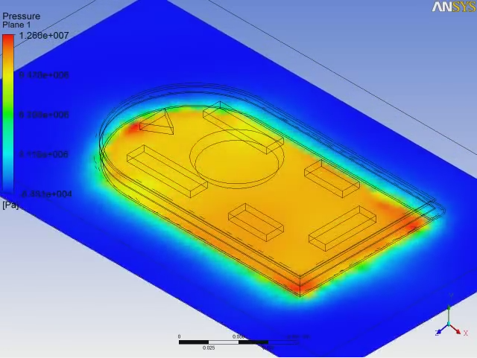 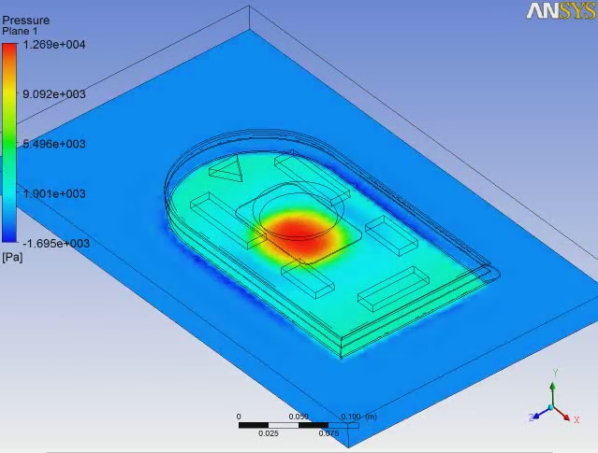

*Pressure distribution contour for Momentum Curtain Theory and Plenum Theory*

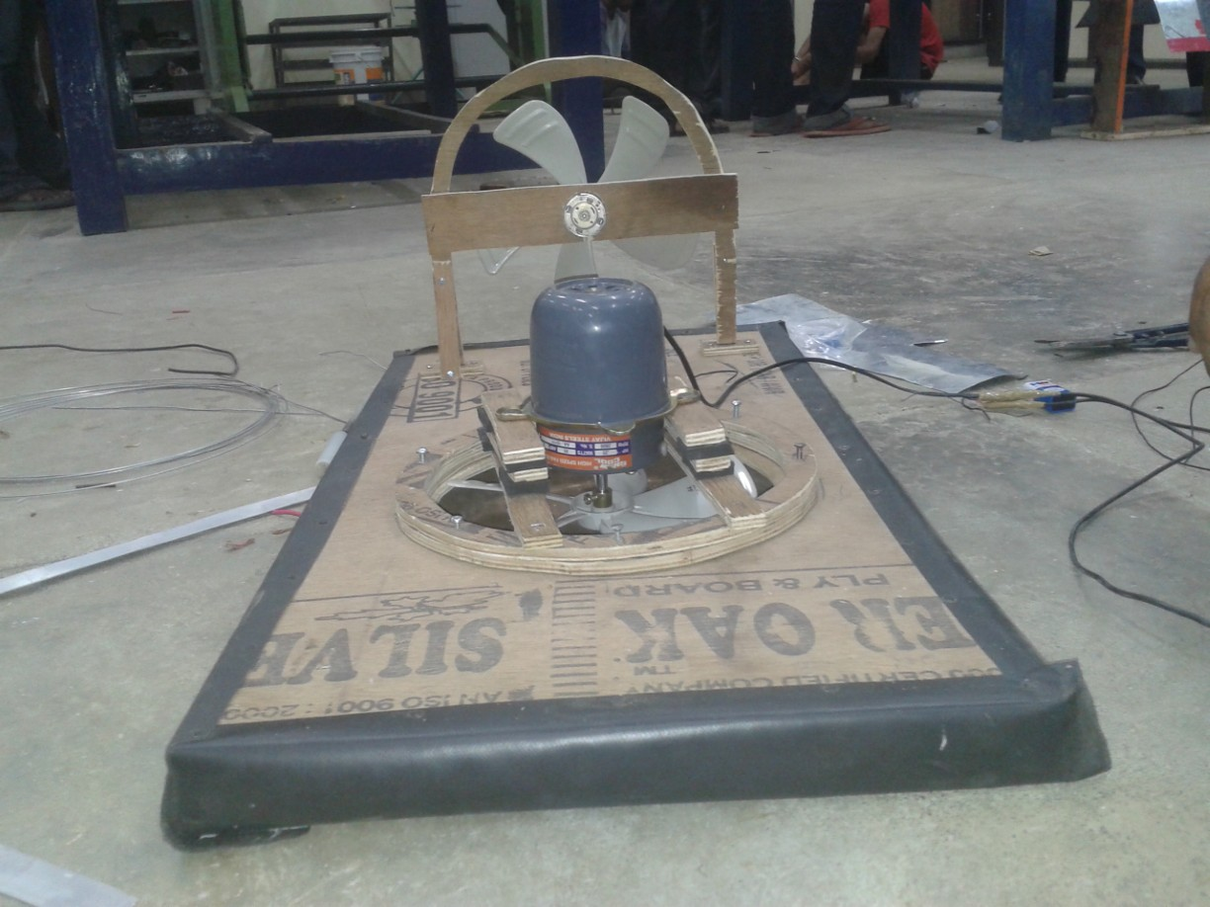

*Fabricated model before installing Rudder, Microcontroller and Battery*